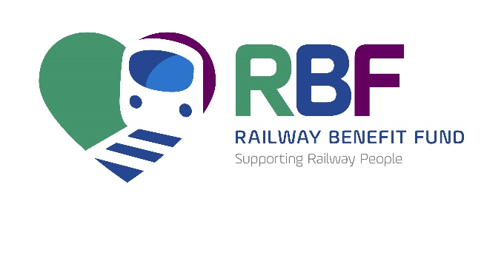 | 1st Floor, Millennium House  40 Nantwich Road,  Crewe, Cheshire.  CW2 6AD  T: 0345 241 2885  www.railwaybenefitfund.org.uk

Payroll Donation Form

MR/MRS/MISS/MS FORENAME: __________________ SURNAME: __________________________________
(BLOCK CAPITALS PLEASE)

HOME ADDRESS: ____________________________________________________________________________
__________________________________________________________ POST CODE: ___________________
TEL: ________________________________________________ DATE OF BIRTH: ___________________
EMAIL ADDRESS: ____________________________________________________________________________

NATIONAL INSURANCE NO :-

JOB TITLE/GRADE: __________________________________________ PAY NO: _____________________
EMPLOYER: ___________________________________ WORK LOCATION: ___________________________
EMPLOYER’S PAYROLL ADDRESS: _____________________________________________________________
____________________________________________________________ POSTCODE: _________________

I authorise the sum of £_____________ per week (suggested minimum donation of £1.50 per week) to be deducted from my pay (from the first available pay run) and paid to the RBF.

SIGNATURE: _____________________________________________ Date: ______________________

From May 2018 we will be only able to contact you if you explicitly say that we can.

To ensure we are able to keep you up to date with news and developments please tick/mark here
************************************************************************************************
Please return completed form to:
RBF, 1st Floor, Millennium House, 40 Nantwich Road Crewe, Cheshire, CW2 6AD
Registered Charity No. 206312 & SCO39550
Or via email to finance@railwaybenefitfund.org.uk

